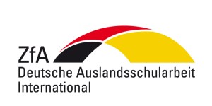
Video Contest Canada 2023 (Ich packe meine Koffer…?) – Media Release Form
Your child’s German Language Class is participating in a video contest organized by the Central Agency for German Schools Abroad (ZfA). To enter the competition, students are encouraged to produce a video clip.
Due to legal provisions, we depend on your consent to publish photographs or video clips of your child on our webpage (www.pasch-net.de), as well as on blogs related to the competition or in a film compilation of the best videos. Pasch-net.de is a pedagogical network of German Language teachers and students with its competition section open only to registered users (schools). A video/film compilation shall only be used for didactic or promotional purposes in schools or at teacher conferences.
We hereby assure to check each photograph/video before publishing it. Neither family (last) names nor further personal data, or portraits of a single child or close-ups will be published.
Please confirm your agreement here – thank you:
I hereby provide consent for photographs/video clips of my child to be posted to the website www.pasch-net.de, as well on related blogs and on the social media sites of the Central Agency for German Schools Abroad (ZfA), the Embassy or the Consulates of the Federal Republic of Germany and participating schools or to be used for didactic/promotional purposes.
□ yes
□ no
Name of Child ____________________________________________________
Name of School, City and Province ____________________________________________________

_______________________________ ___________________________________________________
City, date Signature of parent/guardian/care-giver

